**PREDICTING DIABETES IN HEALTHY POPULATON THROUGH ML**

**PROBLEM STATEMENT**

The problem statement of this Project: To build a machine learning model that can detect weather the person is diabetic person or not dataset information provided. The model is intended to be used as a reference tool for the doctors to help make decisions on the particular humans while he get results weather its positive or negative

**OBJECTIVE:**

The Main objective of this project is detected whether a patient have Diabetes or not and to know this, we used classification techniques of Decision Trees, Random Forest, Logistic Regression, ANN, SVM and hybrid model

**ABSTRACT**

Diabetes is a disease that has no permanent cure; hence early detection is required. Data mining, machine learning (ML) algorithms, and Neural Network (NN) methods are used in diabetes prediction in our research. We used the Pima Indian Diabetes (PID) dataset for our research, collected from the UCI Machine Learning Repository. The dataset contains information about 768 patients and their corresponding nine unique attributes. We used seven ML algorithms on the dataset to predict diabetes. We found that the model with Logistic Regression (LR) and Support Vector Machine (SVM) works well on diabetes prediction. We built the NN model with a different hidden layer with various epochs and observed the NN with two hidden layers

**Keywords:** Decision Trees, Random Forest Logistic Regression, ANN, Hybrid Model

**CHAPTER 1**

**INTRODUCTION**

The WHO (World Health Organization) reported that around 1.6 million people die due to diabetes every year. Diabetes is one kind of disease that occurs when the blood glucose/blood sugar level in the human body is very high. According to health experts, diabetes occurs when the human body’s gland called the pancreas cannot produce enough insulin (Type 1 diabetes), and the produced insulin cannot be used by the cell of the body (Type 2 diabetes) When we eat food, after the digestion process, glucose gets released. Insulin is a blood hormone that moves from blood to cells and instructs cells to consume blood glucose and transform it into energy. When the pancreas cannot produce enough insulin, the cells cannot absorb glucose, and the glucose remains in the blood. Hence the blood glucose/blood sugar increases in the blood at a very unacceptable level. Due to high blood sugar, some symptom arises in the human body, such as extreme hunger, intense thirst, and frequent urination. The usual range of glucose levels in the human body is 70 to 99 mg per deciliter. If the glucose level is more than 126 mg/dl, it indicates diabetes. A person is considered to have prediabetes if body glucose concentration is 100 to 125 mg/dl If

the human body’s blood sugar level becomes too high, the impending complications can be heart disease, kidney failure, stroke, and nerve damage. There is no permanent cure for diabetes. The most common long-term diabetes causes health problems, which are macrovascular and microvascular complications. The macrovascular complication is damage to the large blood vessels of the heart, brain, and legs. Microvascular complication damages the small blood vessels, causing problems in the kidneys, eyes, feet, and nerve. The efficient control of diabetes is possible if it can be detected early. Maintaining an effective fitness system and balanced eating habits can help to prevent diabetes. If a patient has prediabetes, losing bodyweight by getting physical activity can lower the risk of developing Type 2 diabetes. The Center for Disease Control and Prevention (CDC)-led National Diabetes Prevention Program, a lifestyle change program, can help to change a prediabetes patient’s lifestyle and prevent developing Type 2 diabetes. The healthcare industry collects an enormous amount of data include hospital records, medical records of patients, and results of medical examinations. For early disease diagnosis, the disease’s prediction is analyzed through a doctor’s experience and knowledge, but that can be inaccurate and susceptible. Hence the manual decisions can be alarming. The hidden pattern of data can be unnoticed, which can impact decision-making; therefore, patients become deprived of the appropriate treatment. Automated identification with better accuracy is essential for the early detection of diabetes.

Data mining and machine learning have been developing, reliable, and supporting tools in the medical domain in recent years. The data mining method is used to preprocess and select the relevant features from the healthcare data, and the machine learning method helps automate diabetes prediction. Data mining and machine learning algorithms can help identify the hidden pattern of data using the cutting-edge method; hence, a reliable accuracy decision is possible. Data Mining is a process where several techniques are involved, including machine learning, statistics, and database system to discover a pattern from the massive amount of dataset. According to Nvidia: Machine learning uses various algorithms to learn from the parsed data and make predictions.

.

**CHAPTER 2**

**LITERATURE REVIEW**

**[1].G. Swapna, R. Vinayakumar, K.P. Soman, Soman KP diabetes detection using deep learning algorithms, ICT Express 4 (4) (2018) 243–246, http://dx.doi.org/10.1016/j.icte.2018.10.005, Elsevier B.V.**

Diabetes is a metabolic disease affecting a multitude of people worldwide. Its incidence rates are increasing alarmingly every year. If untreated, diabetes-related complications in many vital organs of the body may turn fatal. Early detection of diabetes is very important for timely treatment which can stop the disease progressing to such complications. RR-interval signals known as heart rate variability (HRV) signals (derived from electrocardiogram (ECG) signals) can be effectively used for the non-invasive detection of diabetes. This research paper presents a methodology for [classification](https://www.sciencedirect.com/topics/computer-science/classification) of diabetic and normal HRV signals using deep learning architectures. We employ long short-term memory (LSTM), [convolutional neural network](https://www.sciencedirect.com/topics/engineering/convolutional-neural-network) (CNN) and its combinations for extracting complex temporal dynamic features of the input HRV data. These features are passed into [support vector machine](https://www.sciencedirect.com/topics/engineering/support-vector-machine) (SVM) for classification. We have obtained the performance improvement of 0.03% and 0.06% in CNN and CNN-LSTM architecture respectively compared to our earlier work without using SVM. The classification system proposed can help the clinicians to diagnose diabetes using ECG signals with a very high accuracy of 95.7%

**Summary:** now a days humans can get unidentified diseases there is no medicine for like diseases as a discussion diabetes is also not having any treatment and medicine to cure but we are take some precautions for prevention

**[2].D. Sisodia, D.S. Sisodia, Prediction of diabetes using classification algorithms, Procedia Comput. Sci. 132 (2018) 1578–1585.**

Diabetes is considered as one of the deadliest and chronic diseases which causes an increase in blood sugar. Many complications occur if diabetes remains untreated and unidentified. The tedious identifying process results in visiting of a patient to a diagnostic center and consulting doctor. But the rise in machine learning approaches solves this critical problem. The motive of this study is to design a model which can prognosticate the likelihood of diabetes in patients with maximum accuracy. Therefore three machine learning classification algorithms namely Decision Tree, SVM and Naive Bayes are used in this experiment to detect diabetes at an early stage. Experiments are performed on Pima Indians Diabetes Database (PIDD) which is sourced from UCI machine learning repository. The performances of all the three algorithms are evaluated on various measures like Precision, Accuracy, F-Measure, and Recall. Accuracy is measured over correctly and incorrectly classified instances. Results obtained show Naive Bayes outperforms with the highest accuracy of 76.30% comparatively other algorithms. These results are verified using Receiver Operating Characteristic (ROC) curves in a proper and systematic manner.

**Summary:** for diabetes identification go the endocrinologists for earlier identification and fallow the precautions to cure there is no medicine for diabetes and fallow some diet and take healthy food

**[3].N.P. Tigga, S. Garg, Predicting type 2 Diabetes using Logistic Regression accepted to publish in: Lecture Notes of Electrical Engineering, Springer.**

Type 2 diabetes is possibly going to be the most significant plague in the history of mankind. If we bring all the diabetic people from around the world together, it can form the third-largest nation in the world. Lately, the predominance of diabetes has altogether expanded in India by 13%. While diet and change in the art of living are the foundation to control type 2 diabetes, most of the patients in the long run require medications to control glucose and related health problems. Therefore, early diagnosis and treatment are important to restrain from future complications. This study uses logistic regression, a popular machine learning classification algorithm to predict the risk of type 2 diabetes among individuals. The aim of this study is to improve prediction so that the logistic regression algorithm can be used on any dataset to give result with good accuracy. The Pima Indian Diabetes dataset is taken for analysis, and RStudio is used to process and visualize the result. Our model is showing pretty good prediction with an accuracy of 75.32%. This study will help the future researchers to develop new interventions to reduce the prevalence of diabetes.

**Summary:** basically in diabetes divided into two types type-1, type-2 both are same but type1 is more chances to get easily type2 is getting some health issues if anyone is suffering

**[4].Q. Zou, K. Qu, Y. Luo, D. Yin, Y. Ju, H. Tang, Predicting Diabetes Mellitus with Machine Learning Techniques, Vol. 9, Frontiers in genetics, 2018, p. 515**

Diabetes mellitus is a chronic disease characterized by hyperglycemia. It may cause many complications. According to the growing morbidity in recent years, in 2040, the world’s diabetic patients will reach 642 million, which means that one of the ten adults in the future is suffering from diabetes. There is no doubt that this alarming figure needs great attention. With the rapid development of machine learning, machine learning has been applied to many aspects of medical health. In this study, we used decision tree, random forest and neural network to predict diabetes mellitus. The dataset is the hospital physical examination data in Luzhou, China. It contains 14 attributes. In this study, five-fold cross validation was used to examine the models. In order to verity the universal applicability of the methods, we chose some methods that have the better performance to conduct independent test experiments. We randomly selected 68994 healthy people and diabetic patients’ data, respectively as training set. Due to the data unbalance, we randomly extracted 5 times data. And the result is the average of these five experiments. In this study, we used principal component analysis (PCA) and minimum redundancy maximum relevance (mRMR) to reduce the dimensionality. The results showed that prediction with random forest could reach the highest accuracy (ACC = 0.8084) when all the attributes were used.

**Summary:** more over the worldday to day life increasing diabetes peoples due to food and vitamins problem for this take healthy food and maintain body fit

**SYSTEM ANALYSIS & FEASIBILITY STUDY**

**EXISTING SYSTEM:**

The increasing growth of machine learning, computer techniques divided into traditional methods and machine learning methods. This section describes the related works of Diabetes Prediction Using Different Machine Learning Classifiers and how machine learning methods are better than traditional methods. The existing method in this project have a certain flow is used for model development. Decision Trees, Random Forest, ANN, SVC are used algorithms in existing system. But it requires large memory and result is not accurate.

**Disadvantages:**

* Accuracy low
* Operating cost is high
* difficult to handle

**PROPOSED SYSTEM:**

Proposed several machine learning models model to classify Diabetes or not, but none have adequately addressed this misdiagnosis problem. That can be used for this purpose are Stevens Multi a Diabetes Prediction Using Different Machine Learning Classifiers. Also, similar studies that have proposed models for evaluation of such tumours mostly do not consider the heterogeneity and the size of the data Therefore, we propose a machine learning-based approach which combines a new technique of pre-processing the data for features transformation, classifications hybrid algorithm, Logistic Regression. These both ML algorithms give the best accuracy techniques to eliminate the bias and the deviation of instability and performing classifier tests based.

**Flow Chart:**

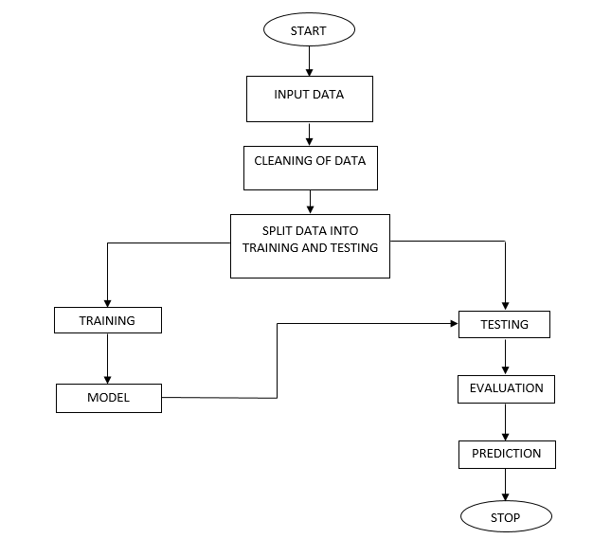

**Fig. Block diagram of proposed method**

**Advantages:**

* Highest accuracy
* Reduces time complexity.

**METHODOLOGY AND ALGORITHMS**

**1.RANDOM FOREST:**

**Ensemble methods** is a machine learning technique that combines several base models in order to produce one optimal predictive model. To better understand this definition lets take a step back into ultimate goal of machine learning and model building. This is going to make more sense as I dive into specific examples and why Ensemble methods are used.

I will largely utilize Decision Trees to outline the definition and practicality of Ensemble Methods (however it is important to note that Ensemble Methods do not only pertain to Decision Trees).

A Decision Tree determines the predictive value based on series of questions and conditions. For instance, this simple Decision Tree determining on whether an individual should play outside or not. The tree takes several weather factors into account, and given each factor either makes a decision or asks another question. In this example, every time it is overcast, we will play outside. However, if it is raining, we must ask if it is windy or not? If windy, we will not play. But given no wind, tie those shoelaces tight because were going outside to play.

When making Decision Trees, there are several factors we must take into consideration: On what features do we make our decisions on? What is the threshold for classifying each question into a yes or no answer? In the first Decision Tree, what if we wanted to ask ourselves if we had friends to play with or not. If we have friends, we will play every time. If not, we might continue to ask ourselves questions about the weather. By adding an additional question, we hope to greater define the Yes and No classes.

This is where Ensemble Methods come in handy! Rather than just relying on one Decision Tree and hoping we made the right decision at each split, Ensemble Methods allow us to take a sample of Decision Trees into account, calculate which features to use or questions to ask at each split, and make a final predictor based on the aggregated results of the sampled Decision Trees.

BAGGing, or Bootstrap AGGregating. **BAGG**ing gets its name because it combines Bootstrapping and Aggregation to form one ensemble model. Given a sample of data, multiple bootstrapped subsamples are pulled. A Decision Tree is formed on each of the bootstrapped subsamples. After each subsample Decision Tree has been formed, an algorithm is used to aggregate over the Decision Trees to form the most efficient predictor. The image below will help explain:

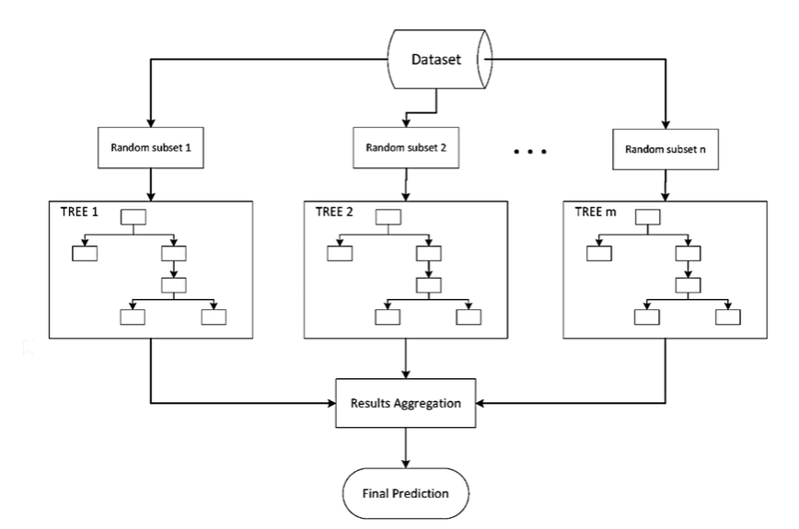

**Random Forest** Models. Random Forest Models can be thought of as **Bagg**ing, with a slight tweak. When deciding where to split and how to make decisions, Bagged Decision Trees have the full disposal of features to choose from. Therefore, although the bootstrapped samples may be slightly different, the data is largely going to break off at the same features throughout each model. In contrary, Random Forest models decide where to split based on a random selection of features. Rather than splitting at similar features at each node throughout, Random Forest models implement a level of differentiation because each tree will split based on different features. This level of differentiation provides a greater ensemble to aggregate over, ergo producing a more accurate predictor. Refer to the image for a better understanding.

**2.DECISION TREE:**

A tree has many analogies in real life, and turns out that it has influenced a wide area of machine learning, covering both classification and regression. In decision analysis, a decision tree can be used to visually and explicitly represent decisions and decision making. As the name goes, it uses a tree-like model of decisions. Though a commonly used tool in data mining for deriving a strategy to reach a particular goal. A decision tree is drawn upside down with its root at the top. In the image on the left, the bold text in black represents a condition/internal node, based on which the tree splits into branches/ edges. The end of the branch that doesn’t split anymore is the decision/leaf, in this case, whether the passenger died or survived, represented as red and green text respectively.

Although, a real dataset will have a lot more features and this will just be a branch in a much bigger tree, but you can’t ignore the simplicity of this algorithm. The feature importance is clear and relations can be viewed easily. This methodology is more commonly known as learning decision tree from data and above tree is called Classification tree as the target is to classify passenger as survived or died. Regression trees are represented in the same manner, just they predict continuous values like price of a house. In general, Decision Tree algorithms are referred to as CART or Classification and Regression Trees.

So, what is actually going on in the background? Growing a tree involves deciding on which features to choose and what conditions to use for splitting, along with knowing when to stop. As a tree generally grows arbitrarily, you will need to trim it down for it to look beautiful. Let’s start with a common technique used for splitting

**3.LOGISTIC REGRESSION:**

Logistic Regression was used in the biological sciences in early twentieth century. It was then used in many social science applications. Logistic Regression is used when the dependent variable (target) is categorical.

For example,

To predict whether an email is spam (1) or (0)

Whether the tumor is malignant (1) or not (0)

Consider a scenario where we need to classify whether an email is spam or not. If we use linear regression for this problem, there is a need for setting up a threshold based on which classification can be done. Say if the actual class is malignant, predicted continuous value 0.4 and the threshold value is 0.5, the data point will be classified as not malignant which can lead to serious consequence in real time.

From this example, it can be inferred that linear regression is not suitable for classification problem. Linear regression is unbounded, and this brings logistic regression into picture. Their value strictly ranges from 0 to 1.

**Purpose and examples of logistic regression:**

Logistic regression is one of the most commonly used machine learning algorithms for binary classification problems, which are problems with two class values, including predictions such as “this or that,” “yes or no” and “A or B.”

The purpose of logistic regression is to estimate the probabilities of events, including determining a relationship between features and the probabilities of particular outcomes.

One example of this is predicting if a student will pass or fail an exam when the number of hours spent studying is provided as a feature and the variables for the response has two values: pass and fail.

Organizations can use insights from logistic regression outputs to enhance their business strategies so they can achieve their business goals, including reducing expenses or losses and increasing [ROI](https://searchcio.techtarget.com/definition/ROI) in marketing campaigns, for example.

An [e-commerce](https://searchcio.techtarget.com/definition/e-commerce) company that mails expensive promotional offers to customers would like to know whether a particular customer is likely to respond to the offers or not. For example, they’ll want to know whether that consumer will be a “responder” or a “non responder.” In marketing, this is called propensity to respond modeling.

Likewise, a credit card company develops a model to decide whether to issue a credit card to a customer or not will try to predict whether the customer is going to default or not on the credit card based on such characteristics as annual income, monthly credit card payments and number of defaults. In banking parlance, this is known as default propensity modeling.

**Uses of logistic regression:**

Logistic regression has become particularly popular in online advertising, enabling marketers to predict the likelihood of specific website users who will click on particular advertisements as a yes or no percentage.

* Logistic regression can also be used in:
* Healthcare to identify risk factors for diseases and plan preventive measures.
* Weather forecasting [apps](https://searchsoftwarequality.techtarget.com/definition/application) to predict snowfall and weather conditions.
* Voting apps to determine if voters will vote for a particular candidate.

Insurance to predict the chances that a policy holder will die before the term of the policy expires based on certain criteria, such as gender, age and physical examination.

Banking to predict the chances that a loan applicant will default on a loan or not, based on annual income, past defaults and past debts.

**Logistic regression vs. linear regression:**

The main difference between logistic regression and linear regression is that logistic regression provides a constant output, while linear regression provides a continuous output.

In logistic regression, the outcome, such as a dependent variable, only has a limited number of possible values. However, in linear regression, the outcome is continuous, which means that it can have any one of an infinite number of possible values.

Logistic regression is used when the response variable is categorical, such as yes/no, true/false and pass/fail. Linear regression is used when the response variable is continuous, such as number of hours, height and weight.

For example, given data on the time a student spent studying and that student’s exam scores, logistic regression and linear regression can predict different things.

With logistic regression predictions, only specific values or categories are allowed. Therefore, logistic regression can predict whether the student passed or failed. Since linear regression predictions are continuous, such as numbers in a range, it can predict the student’s test score on a scale of 0 -100.

**4.SUPPORT VECTOR MACHINES:**

The objective of the support vector machine algorithm is to find a hyper plane in an N-dimensional space (N — the number of features) that distinctly classifies the data points.

**Possible hyper planes :**

To separate the two classes of data points, there are many possible Hyper planes that could be chosen. Our objective is to find a plane that has the maximum margin, i.e. the maximum distance between data points of both classes. Maximizing the margin distance provides some reinforcement so that future data points can be classified with more confidence.

## Hyper planes and Support Vectors

**Hyper planes in 2D and 3D feature space**

Hyper planes are decision boundaries that help classify the data points. Data points falling on either side of the hyper plane can be attributed to different classes. Also, the dimension of the hyper plane depends upon the number of features. If the number of input features is 2, then the hyper plane is just a line. If the number of input features is 3, then the hyper plane becomes a two-dimensional plane. It becomes difficult to imagine when the number of features exceeds 3.

**Support Vectors**

Support vectors are data points that are closer to the hyper plane and influence the position and orientation of the hyper plane. Using these support vectors, we maximize the margin of the classifier. Deleting the support vectors will change the position of the hyper plane. These are the points that help us build our SVM.

**Large Margin Intuition**

In logistic regression, we take the output of the linear function and squash the value within the range of [0,1] using the sigmoid function. If the squashed value is greater than a threshold value (0.5) we assign it a label 1, else we assign it a label 0. In SVM, we take the output of the linear function and if that output is greater than 1, we identify it with one class and if the output is -1, we identify is with another class. Since the threshold values are changed to 1 and -1 in SVM, we obtain this reinforcement range of values ([-1, 1]) which acts as margin.

**Cost Function and Gradient Updates**

In the SVM algorithm, we are looking to maximize the margin between the data points and the hyper plane. The loss function that helps maximize the margin is hinge loss.

Hinge loss function (function on left can be represented as a function on the right)

The cost is 0 if the predicted value and the actual value are of the same sign. If they are not, we then calculate the loss value. We also add a regularization parameter the cost function. The objective of the regularization parameter is to balance the margin maximization and loss. After adding the regularization parameter, the cost functions looks as below.

**Loss function for SVM**

Now that we have the loss function, we take partial derivatives with respect to the weights to find the gradients. Using the gradients, we can update our weights.

Gradients

When there is no misclassification, i.e. our model correctly predicts the class of our data point, we only have to update the gradient from the regularization parameter.

Gradient Update — No misclassification

When there is a misclassification, i.e. our model make a mistake on the prediction of the class of our data point, we include the loss along with the regularization parameter to perform gradient update.

**5.ARTIFICIAL** **NEURAL NETWORKS:**

An artificial neural network (ANN) is the piece of a computing system designed to simulate the way the human brain analyzes and processes information. It is the foundation of artificial intelligence (AI) and solves problems that would prove impossible or difficult by human or statistical standards. ANNs have self-learning capabilities that enable them to produce better results as more data becomes available.

An ANN has hundreds or thousands of artificial neurons called processing units, which are interconnected by nodes. These processing units are made up of input and output units. The input units receive various forms and structures of information based on an internal weighting system, and the neural network attempts to learn about the information presented to produce one output report. Just like humans need rules and guidelines to come up with a result or output, ANNs also use a set of learning rules called backpropagation, an abbreviation for backward propagation of error, to perfect their output results.

An ANN initially goes through a training phase where it learns to recognize patterns in data, whether visually, aurally, or textually. During this supervised phase, the network compares its actual output produced with what it was meant to produce—the desired output. The difference between both outcomes is adjusted using backpropagation. This means that the network works backward, going from the output unit to the input units to adjust the weight of its connections between the units until the difference between the actual and desired outcome produces the lowest possible error.

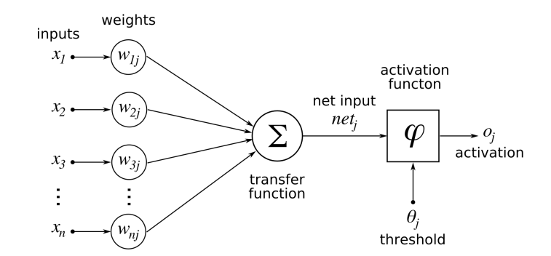

Whenever we increase the layers in our ANN then it is nothing but our Deep Neural Networks.

A **deep neural network** (DNN) is an artificial **neural network** (ANN) with multiple layers between the input and output layers. There are different types of **neural networks** but they always consist of the same components: neurons, synapses, weights, biases, and functions.

# **Stacking in Machine Learning**

There are many ways to ensemble models in machine learning, such as Bagging, Boosting, and stacking. Stacking is one of the most popular ensemble machine learning techniques used to predict multiple nodes to build a new model and improve model performance**.** Stacking enables us to train multiple models to solve similar problems, and based on their combined output, it builds a new model with improved performance.

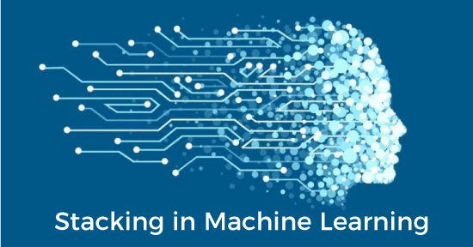

In this topic, "**Stacking in Machine Learning**", we will discuss a few important concepts related to stacking, the general architecture of stacking, important key points to implement stacking, and how stacking differs from **bagging** and **boosting** in machine learning. Before starting this topic, first, understand the concepts of the ensemble in machine learning. So, let's start with the definition of ensemble learning in machine learning.

## **What is Ensemble learning in Machine Learning?**

Ensemble learning is one of the most powerful machine learning techniques that use the combined output of two or more models/weak learners and solve a particular computational intelligence problem. E.g., a Random Forest algorithm is an ensemble of various decision trees combined.

Ensemble learning is primarily used to improve the model performance, such as classification, prediction, function approximation, etc. In simple words, we can summarise the ensemble learning as follows:

**"**An ensembled model is a machine learning model that combines the predictions from two or more models.”

There are 3 most common ensemble learning methods in machine learning. These are as follows:

* Bagging
* Boosting
* Stacking

However, we will mainly discuss Stacking on this topic.

### **1. Bagging**

Bagging is a method of ensemble modeling, which is primarily used to solve supervised machine learning problems. It is generally completed in two steps as follows:

* **Bootstrapping:** It is a random sampling method that is used to derive samples from the data using the replacement procedure. In this method, first, random data samples are fed to the primary model, and then a base learning algorithm is run on the samples to complete the learning process.
* **Aggregation:** This is a step that involves the process of combining the output of all base models and, based on their output, predicting an aggregate result with greater accuracy and reduced variance.

**Example:** In the Random Forest method, predictions from multiple decision trees are ensembled parallelly. Further, in regression problems, we use an average of these predictions to get the final output, whereas, in classification problems, the model is selected as the predicted class.

### **2. Boosting**

Boosting is an ensemble method that enables each member to learn from the preceding member's mistakes and make better predictions for the future. Unlike the bagging method, in boosting, all base learners (weak) are arranged in a sequential format so that they can learn from the mistakes of their preceding learner. Hence, in this way, all weak learners get turned into strong learners and make a better predictive model with significantly improved performance.

We have a basic understanding of ensemble techniques in machine learning and their two common methods, i.e., bagging and boosting. Now, let's discuss a different paradigm of ensemble learning, i.e., Stacking.

### **3. Stacking**

Stacking is one of the popular ensemble modeling techniques in machine learning. Various weak learners are ensembled in a parallel manner in such a way that by combining them with Meta learners, we can predict better predictions for the future.

This ensemble technique works by applying input of combined multiple weak learners' predictions and Meta learners so that a better output prediction model can be achieved.

In stacking, an algorithm takes the outputs of sub-models as input and attempts to learn how to best combine the input predictions to make a better output prediction.

Stacking is also known as **a stacked generalization** and is an extended form of the Model Averaging Ensemble technique in which all sub-models equally participate as per their performance weights and build a new model with better predictions. This new model is stacked up on top of the others; this is the reason why it is named stacking.

**SOFTWARE DEVELOPMENT LIFE CYCLE – SDLC:**

In our project we use waterfall model as our software development cycle because of its step-by-step procedure while implementing.

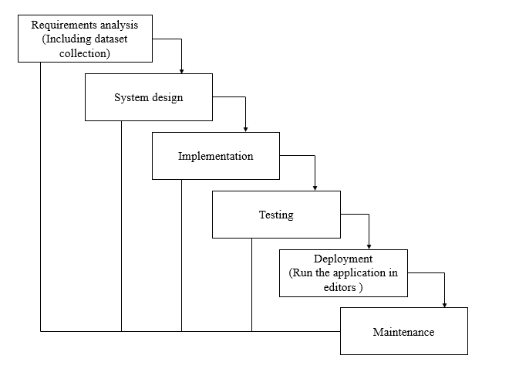

**Fig 3**: Waterfall Model

* **Requirement Gathering and analysis** − all possible requirements of the system to be developed are captured in this phase and documented in a requirement specification document.
* **System Design** − the requirement specifications from first phase are studied in this phase and the system design is prepared. This system design helps in specifying hardware and system requirements and helps in defining the overall system architecture.
* **Implementation** − with inputs from the system design, the system is first developed in small programs called units, which are integrated in the next phase. Each unit is developed and tested for its functionality, which is referred to as Unit Testing.
* **Integration and Testing** − All the units developed in the implementation phase are integrated into a system after testing of each unit. Post integration the entire system is tested for any faults and failures.
* **Deployment of system** − Once the functional and non-functional testing is done; the product is deployed in the customer environment or released into the market.
* **Maintenance** − There are some issues which come up in the client environment. To fix those issues, patches are released. Also, to enhance the product some better versions are released. Maintenance is done to deliver these changes in the customer environment.

**FEASIBILITY STUDY**

The feasibility of the project is analysed in this phase and business proposal is put forth with a very general plan for the project and some cost estimates. During system analysis the feasibility study of the proposed system is to be carried out. This is to ensure that the proposed system is not a burden to the company. For feasibility analysis, some understanding of the major requirements for the system is essential.

Three key considerations involved in the feasibility analysis are

* ECONOMICAL FEASIBILITY
* TECHNICAL FEASIBILITY
* SOCIAL FEASIBILITY

**Economic feasibility:**

This study is carried out to check the economic impact that the system will have on the organization. The amount of fund that the company can pour into the research and development of the system is limited. The expenditures must be justified. Thus, the developed system as well within the budget and this was achieved because most of the technologies used are freely available. Only the customized products had to be purchased.

### Technical feasibility:

This study is carried out to check the technical feasibility, that is, the technical requirements of the system. Any system developed must not have a high demand on the available technical resources. This will lead to high demands on the available technical resources. This will lead to high demands being placed on the client. The developed system must have a modest requirement, as only minimal or null changes are required for implementing this system.

**Social feasibility:**

The aspect of study is to check the level of acceptance of the system by the user. This includes the process of training the user to use the system efficiently. The user must not feel threatened by the system, instead must accept it as a necessity. The level of acceptance by the users solely depends on the methods that are employed to educate the user about the system and to make him familiar with it. His level of confidence must be raised so that he is also able to make some constructive criticism, which is welcomed, as he is the final user of the system.

**SYSTEM REQUIREMENTS SPECIFICATION**

**Functional and non-functional requirements:**

Requirement’s analysis is very critical process that enables the success of a system or software project to be assessed. Requirements are generally split into two types: Functional and non-functional requirements.

**Functional Requirements**: These are the requirements that the end user specifically demands as basic facilities that the system should offer. All these functionalities need to be necessarily incorporated into the system as a part of the contract. These are represented or stated in the form of input to be given to the system, the operation performed and the output expected. They are basically the requirements stated by the user which one can see directly in the final product, unlike the non-functional requirements.

Examples of functional requirements:

1. Authentication of user whenever he/she logs into the system
2. System shutdown in case of a cyber-attack
3. A verification email is sent to user whenever he/she register for the first time on some software system.

**Non-functional requirements**: These are basically the quality constraints that the system must satisfy according to the project contract. The priority or extent to which these factors are implemented varies from one project to other. They are also called non-behavioral requirements.  
They basically deal with issues like:

* Portability
* Security
* Maintainability
* Reliability
* Scalability
* Performance
* Reusability
* Flexibility

Examples of non-functional requirements:

1. Emails should be sent with a latency of no greater than 12 hours from such an activity.
2. The processing of each request should be done within 10 seconds
3. The site should load in 3 seconds whenever of simultaneous users are > 10000

**SYSTEM SPECIFICATIONS:**

# **H/W Specifications:**

# Processor : I3/Intel Processor

# RAM : 8GB (min)

* Hard Disk : 128 GB

**S/W Specifications:**

* Operating System : Windows 10
* Server-side Script : Python 3.6
* IDE : PyCharm
* Frame work : Stream Lit
* Libraries Used : NumPy, Pandas, Scikit-Learn.

**SYSTEM DESIGN:**

## **Input Design:**

In an information system, input is the raw data that is processed to produce output. During the input design, the developers must consider the input devices such as PC, MICR, OMR, etc.

Therefore, the quality of system input determines the quality of system output. Well-designed input forms and screens have following properties −

* It should serve specific purpose effectively such as storing, recording, and retrieving the information.
* It ensures proper completion with accuracy.
* It should be easy to fill and straightforward.
* It should focus on user’s attention, consistency, and simplicity.
* All these objectives are obtained using the knowledge of basic design principles regarding −
  + What are the inputs needed for the system?
  + How end users respond to different elements of forms and screens.

### Objectives for Input Design:

The objectives of input design are

* To design data entry and input procedures
* To reduce input volume
* To design source documents for data capture or devise other data capture methods
* To design input data records, data entry screens, user interface screens, etc.
* To use validation checks and develop effective input controls.

**Output Design:**

The design of output is the most important task of any system. During output design, developers identify the type of outputs needed, and consider the necessary output controls and prototype report layouts.

### Objectives of Output Design:

The objectives of input design are:

* To develop output design that serves the intended purpose and eliminates the production of unwanted output.
* To develop the output design that meets the end user’s requirements.
* To deliver the appropriate quantity of output.
* To form the output in appropriate format and direct it to the right person.
* To make the output available on time for making good decisions.

**MODULES**

**System**

1. **User**:
   1. **Registration**:

Here the user should have to register with proper details like name, maid id, password, confirm password, mobile number

**1.2Login:**

Aftercompletingthe registrationuser can login here with the registered details

**1.3View Home page:**

Here user view the home page of the diabetes prediction using ml web application.

**1.4View Upload page:**

In the upload page we can upload dataset in the web application

**1.5split page:**

In split page the data splits into 30% for testing purpose

**1.6Model train:**

After splitting the data is ready for testing here we are train the algorithms to the dataset for prediction

Here user have ability to view the score in %

**1.7 logout:**

After classification the user can logout the account

1. **System**
   1. **Working on dataset:**

System checks for data whether it is available or not and load the data in csv files.

* 1. **Pre-processing:**

Data need to be pre-processed according the models it helps to increase the accuracy of the model and better information about the data.

* 1. **Training the data:**

After pre-processing the data will split into two parts as train and test data before training with the given algorithms.

* 1. **Model Building**

To create a model that predicts the personality with better accuracy, this module will help user.

* 1. **Generated Score:**
  2. Here user view the score in %
  3. **Generate Results:**

We train the machine learning algorithm and predict the person is having diabetes or not

**Architecture:**

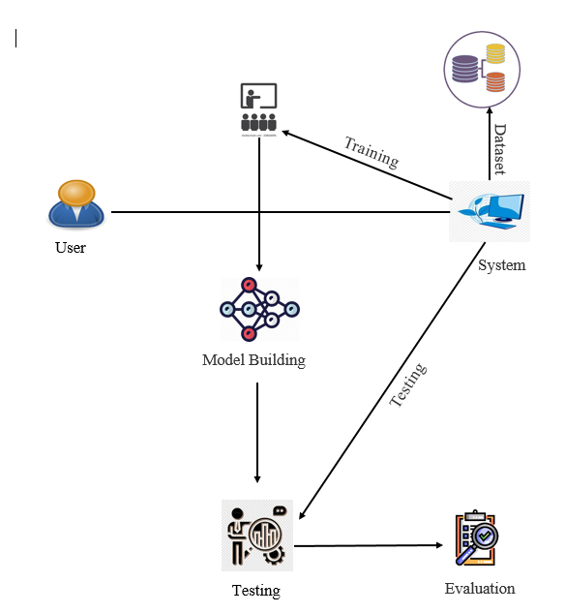

**UML DIAGRAMS**

UML stands for Unified Modelling Language. UML is a standardized general-purpose modelling language in the field of object-oriented software engineering. The standard is managed, and was created by, the Object Management Group.

The goal is for UML to become a common language for creating models of object-oriented computer software. In its current form UML is comprised of two major components: a Meta-model and a notation. In the future, some form of method or process may also be added to; or associated with, UML.

The Unified Modelling Language is a standard language for specifying, Visualization, Constructing and documenting the artifacts of software system, as well as for business modelling and other non-software systems.

The UML represents a collection of best engineering practices that have proven successful in the modelling of large and complex systems.

The UML is a very important part of developing objects-oriented software and the software development process. The UML uses mostly graphical notations to express the design of software projects.

**GOALS:**

The Primary goals in the design of the UML are as follows:

1. Provide users a ready-to-use, expressive visual modelling Language so that they can develop and exchange meaningful models.
2. Provide extendibility and specialization mechanisms to extend the core concepts.
3. Be independent of particular programming languages and development process.
4. Provide a formal basis for understanding the modelling language.
5. Encourage the growth of OO tools market.
6. Support higher level development concepts such as collaborations, frameworks, patterns and components.
7. Integrate best practices.

**USE CASE DIAGRAM**

* A use case diagram in the Unified Modeling Language (UML) is a type of behavioral diagram defined by and created from a Use-case analysis.
* Its purpose is to present a graphical overview of the functionality provided by a system in terms of actors, their goals (represented as use cases), and any dependencies between those use cases.
* The main purpose of a use case diagram is to show what system functions are performed for which actor. Roles of the actors in the system can be depicted.

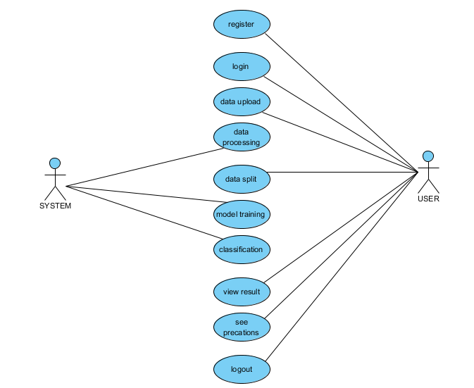

**CLASS DIAGRAM**

In software engineering, a class diagram in the Unified Modeling Language (UML) is a type of static structure diagram that describes the structure of a system by showing the system's classes, their attributes, operations (or methods), and the relationships among the classes. It explains which class contains information

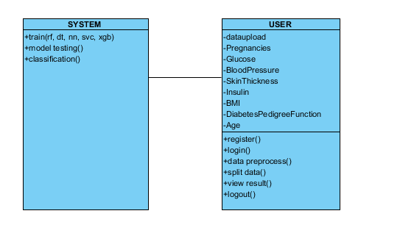

**SEQUENCE DIAGRAM**

* A sequence diagram in Unified Modeling Language (UML) is a kind of interaction diagram that shows how processes operate with one another and in what order.
* It is a construct of a Message Sequence Chart. Sequence diagrams are sometimes called event diagrams, event scenarios, and timing diagrams

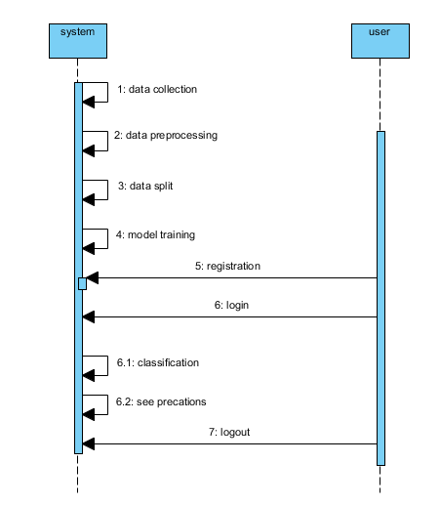

**COLLABORATION DIAGRAM:**

In collaboration diagram the method call sequence is indicated by some numbering technique as shown below. The number indicates how the methods are called one after another. We have taken the same order management system to describe the collaboration diagram. The method calls are similar to that of a sequence diagram. But the difference is that the sequence diagram does not describe the object organization whereas the collaboration diagram shows the object organization.

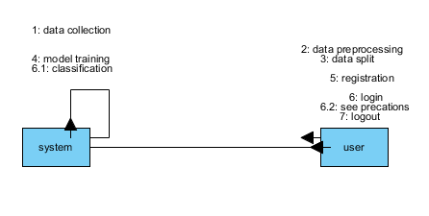

**DEPLOYMENT DIAGRAM**

Deployment diagram represents the deployment view of a system. It is related to the component diagram. Because the components are deployed using the deployment diagrams. A deployment diagram consists of nodes. Nodes are nothing but physical hardware’s used to deploy the application.

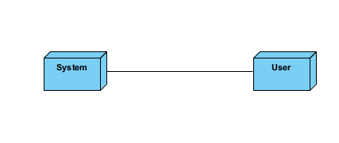

**ACTIVITY DIAGRAM:**

Activity diagrams are graphical representations of workflows of stepwise activities and actions with support for choice, iteration and concurrency. In the Unified Modeling Language, activity diagrams can be used to describe the business and operational step-by-step workflows of components in a system. An activity diagram shows the overall flow of control.

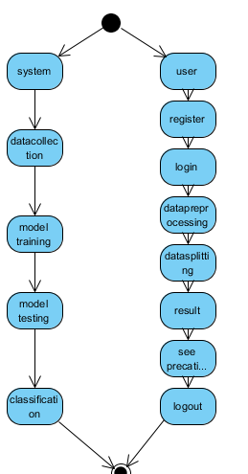

**COMPONENT DIAGRAM**:

A component diagram, also known as a UML component diagram, describes the organization and wiring of the physical **c**omponents in a system. Component diagrams are often drawn to help model implementation details and double-check that every aspect of the system's required function is covered by planned development.

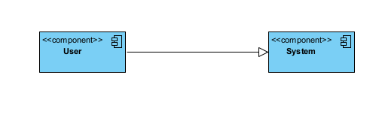

**ER DIAGRAM:**

An Entity–relationship model (ER model) describes the structure of a database with the help of a diagram, which is known as Entity Relationship Diagram (ER Diagram). An ER model is a design or blueprint of a database that can later be implemented as a database. The main components of E-R model are: entity set and relationship set.

An ER diagram shows the relationship among entity sets. An entity set is a group of similar entities and these entities can have attributes. In terms of DBMS, an entity is a table or attribute of a table in database, so by showing relationship among tables and their attributes, ER diagram shows the complete logical structure of a database. Let’s have a look at a simple ER diagram to understand this concept.

# 

**DFD DIAGRAM:**

A Data Flow Diagram (DFD) is a traditional way to visualize the information flows within a system. A neat and clear DFD can depict a good amount of the system requirements graphically. It can be manual, automated, or a combination of both. It shows how information enters and leaves the system, what changes the information and where information is stored. The purpose of a DFD is to show the scope and boundaries of a system as a whole. It may be used as a communications tool between a systems analyst and any person who plays a part in the system that acts as the starting point for redesigning a system.

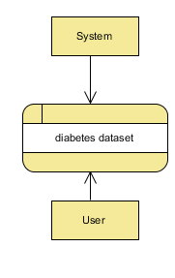

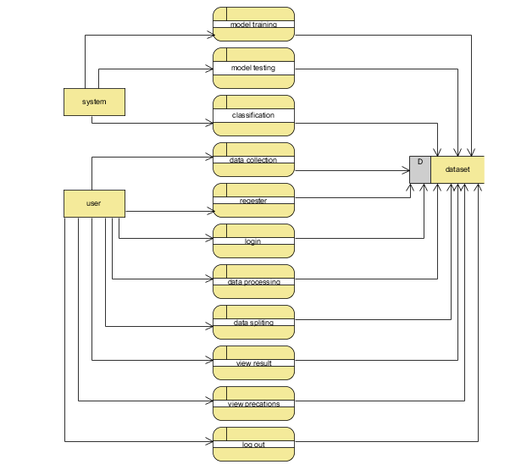

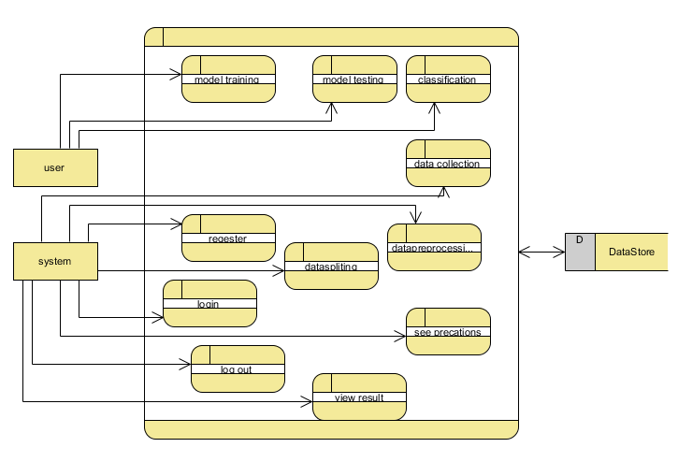

**OUTPUT SCREEN SHOTS WITH DESCRIPTION.**

**Home Page:**

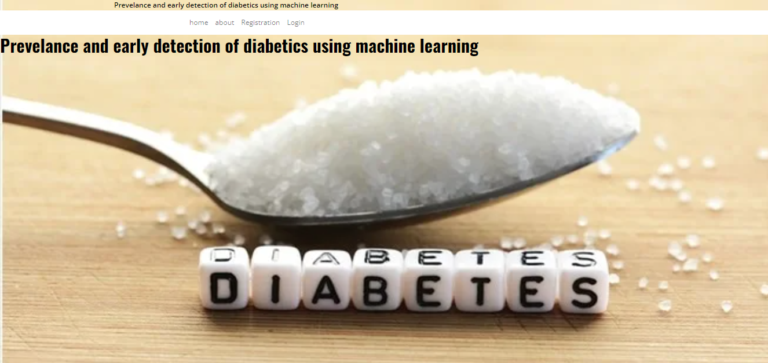

**About page:**

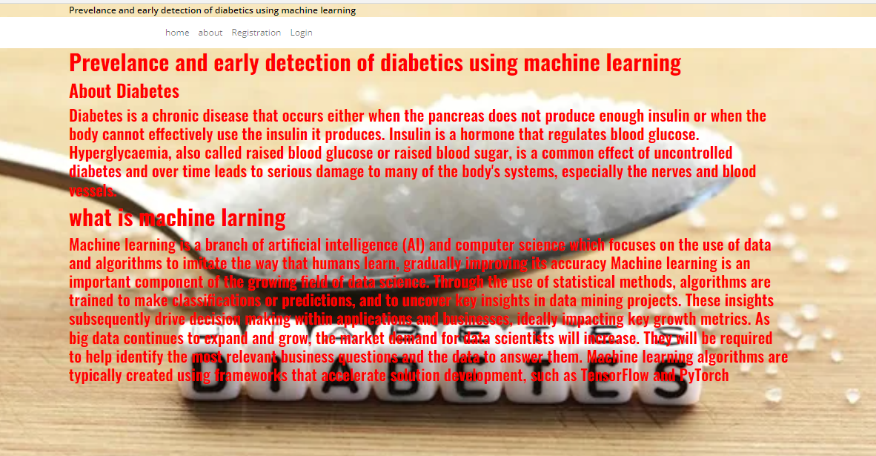

**Register page:**

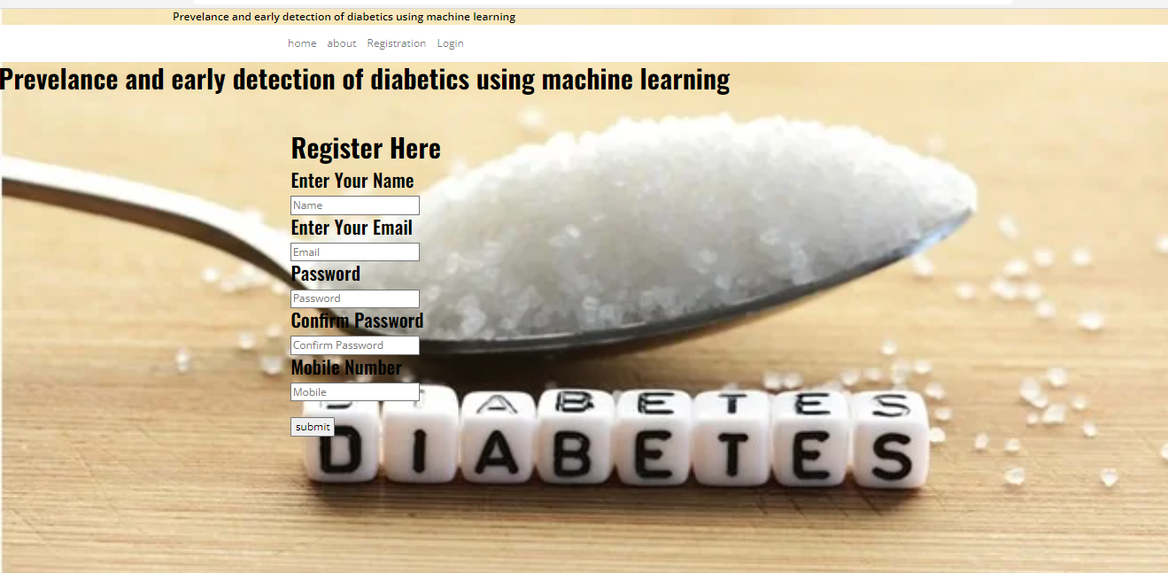

**login page:**

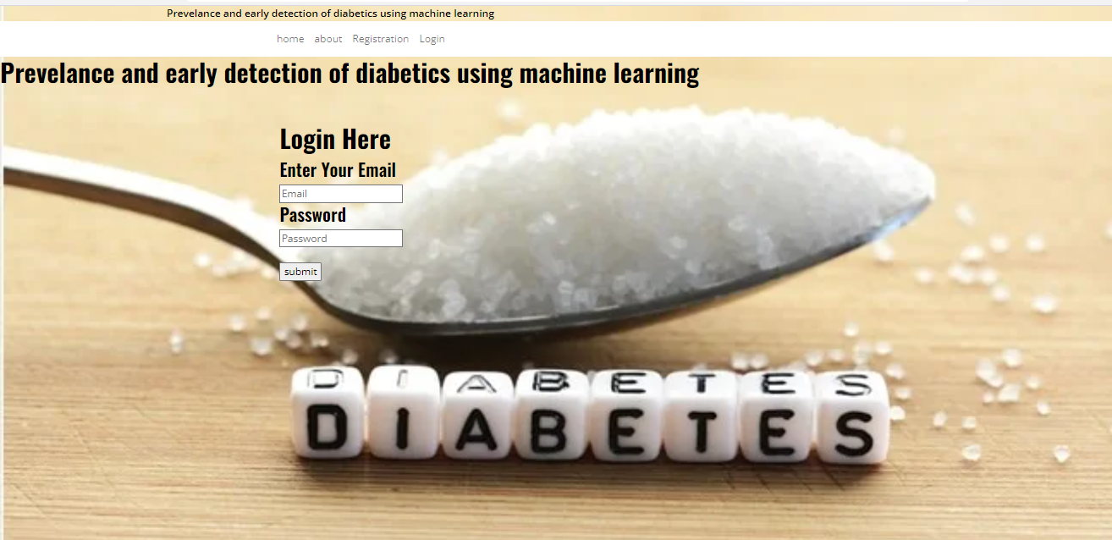

**Upload page:**

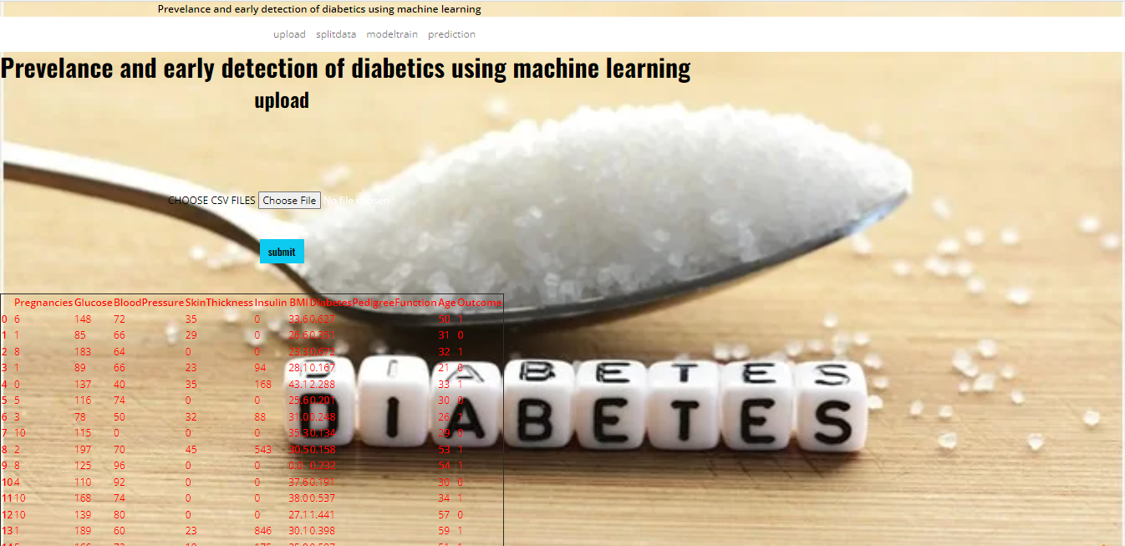

**Split page:**

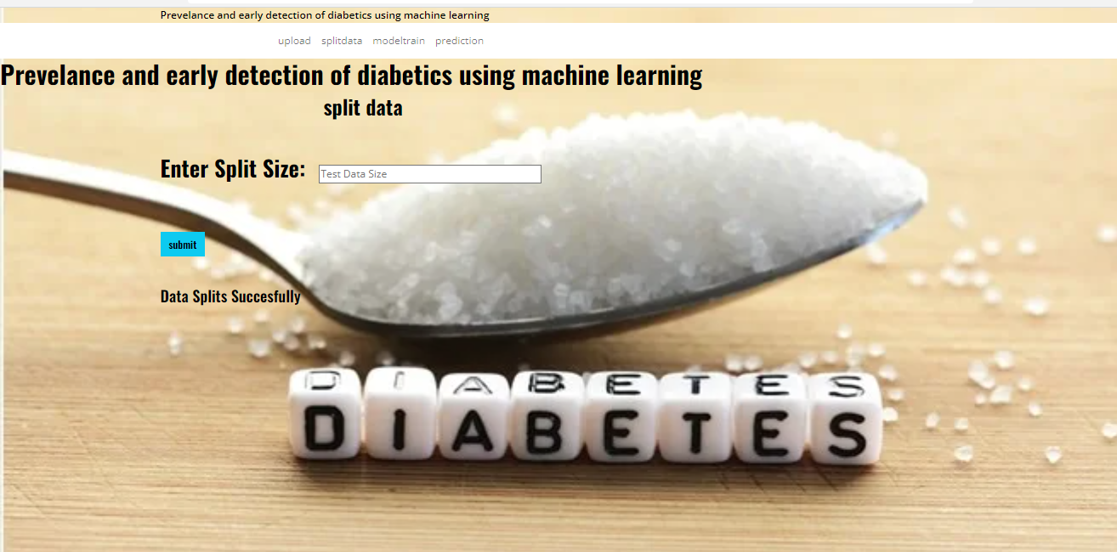

**Model training:**

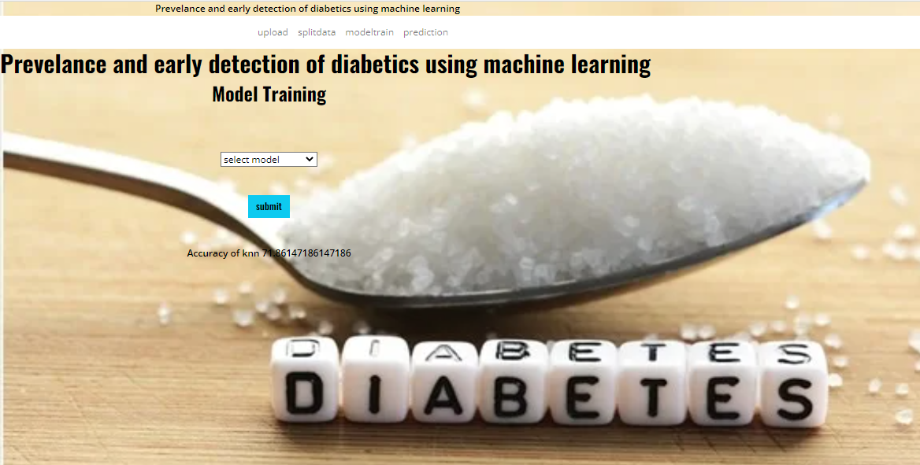

**Prediction:**

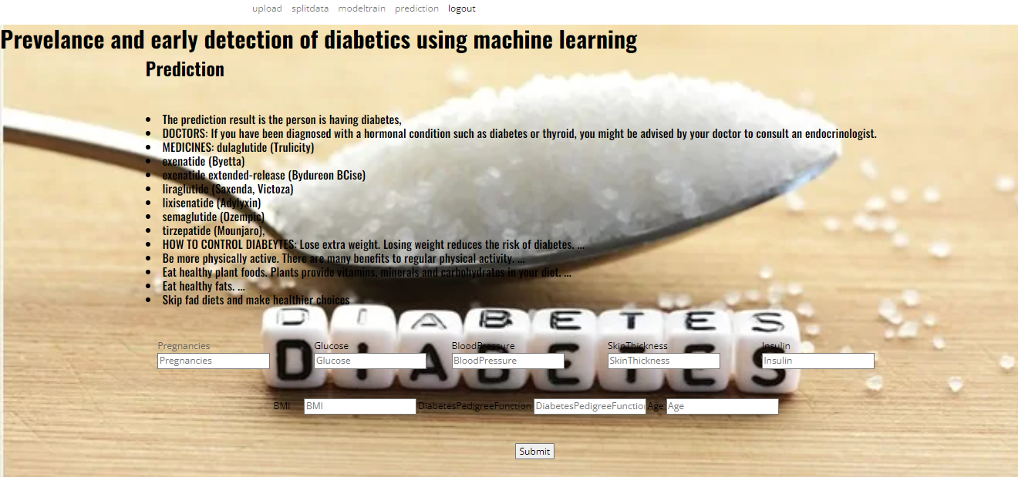

**TEST CASES:**

|  |  |  |
| --- | --- | --- |
| **Input** | **Output** | **Result** |
| Input | Tested for the classifier for  The diabetes prediction | output |

**Test cases Model building:**

|  |  |  |  |  |  |
| --- | --- | --- | --- | --- | --- |
| **S.NO** | **Test cases** | **I/O** | **Expected O/T** | **Actual O/T** | **P/F** |
| 1 | Read the dataset. | Dataset path. | Dataset need to read successfully. | Dataset fetched successfully. | P |
| 2 | Performing pre-processing on the dataset | Pre-processing part takes place | Pre-processing should be performed on dataset | Pre-processing successfully completed. | P |
| 3 | Model Building | Model Building for the clean data | Need to create model using required algorithms | Model Created Successfully. | P |
| 4 | Classification | Input values provided. | Output would be any one of the classifications  Weather the person is having diabetes or not | Model classified successfully | P |

**CONCLUSION:**

The project has concluded that, to know the Techniques for Predicting the person is diabetes person or they not having diabetes in her body for this we used 6 machine learning based methods such as Random Forest, Decision tree etc. techniques to get better accuracy. By using this algorithms we get the Match Results

**FUTURE SCOPE:**

This can be utilized in future to classify the types of different classifications easily that which can tend to easy to find out the diabetes persons using different machine learning algorithms.

**REFERENCES:**   
[1] <https://www.who.int/health-topics/diabetes>.

[2]https://www.medicalnewstoday.com/articles/325018#how-is-the-pancre as-linked-with-diabetes.

[3] <https://www.webmd.com/diabetes/diabetes-causes>.

[4]<https://www.mayoclinic.org/diseases-conditions/prediabetes/diagnosis-treatment/drc-20355284>.

[5]https://www.niddk.nih.gov/healthinformation/diabetes/overview/sympto ms-causes.

[6]https://www.diabetes.co.uk/diabetes_care/blood-sugar-level-ranges.html .

[7]https://www.healthgrades.com/right-care/diabetes/is-there-a-cure-for-di abetes.

[8]https://www.betterhealth.vic.gov.au/health/conditionsandtreatments/dia betes-long-term-effects.

[9] S.A. Kaveeshwar, J. Cornwall, The current state of diabetes mellitus in India, Australas. Med. J. 7 (1) (2014) 45.

[10] https://www.cdc.gov/diabetes/basics/prediabetes.html.

[11] C.L. Huang, M.C. Chen, C.J. Wang, Credit scoring with a data mining approach based on support vector machines, Expert Syst. Appl. 33 (4) (2007) 847–856, <http://dx.doi.org/10.1016/j.eswa.2006.07.007>.

[12] J. Chaki, S. Thillai Ganesh, S.K. Cidham, S. Ananda Theertan, Machine learning and artificial intelligence-based diabetes mellitus detection and self-management: A systematic review, J. King Saud Univ. - Comput. Inf. Sci. (2020).

[13] I. Contreras, J. Vehi, Artificial intelligence for diabetes management and decision support: Literature review, J. Med. Internet Res. 20 (5) (2018) e10775.

[14] G. Swapna, R. Vinayakumar, K.P. Soman, Soman KP diabetes detection using deep learning algorithms, ICT Express 4 (4) (2018) 243–246, http://dx.doi.org/10.1016/j.icte.2018.10.005, Elsevier B.V.

[15] M.W. Craven, J.W. Shavlik, Using neural networks for data mining, Future Gener. Comput. Syst. 13 (2–3) (1997) 211–229, http://dx.doi. org/10.1016/s0167-739x(97)00022-8.

[16] https://blogs.nvidia.com/blog/2016/07/29/whats-difference-artificialintelligence-machine-learning-deep-learning-a

17] T.M. Alam, et al., Informatics in medicine unlocked a model for early prediction of diabetes, Inform. Med. Unlocked 16 (2019) 100204.

[18] D. Sisodia, D.S. Sisodia, Prediction of diabetes using classification algorithms, Procedia Comput. Sci. 132 (2018) 1578–1585.

[19] N.P. Tigga, S. Garg, Predicting type 2 Diabetes using Logistic Regression accepted to publish in: Lecture Notes of Electrical Engineering, Springer.

[20] Salim Amour Diwani, Anael Sam, Diabetes forecasting using supervised learning techniques, Adv. Comput. Sci.: Int. J. [S.l.] (ISSN: 2322-5157) (2014) 10–18, Available at:

**BIBLIOGRAPHY:**

**SOFTWARE INSTALLATION FOR MACHINE LEARNING PROJECTS:**

**Installing Python:**

1. To download and install Python visit the official website of Python <https://www.python.org/downloads/> and choose your version.

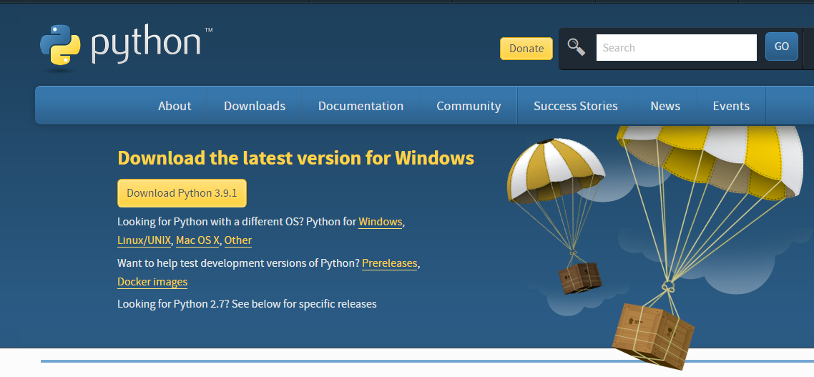

1. Once the download is complete, run the exe for install Python. Now click on Install Now.
2. You can see Python installing at this point.
3. When it finishes, you can see a screen that says the Setup was successful. Now click on "Close".

**Installing PyCharm:**

1. To download PyCharm visit the website <https://www.jetbrains.com/pycharm/download/> and click the "DOWNLOAD" link under the Community Section.

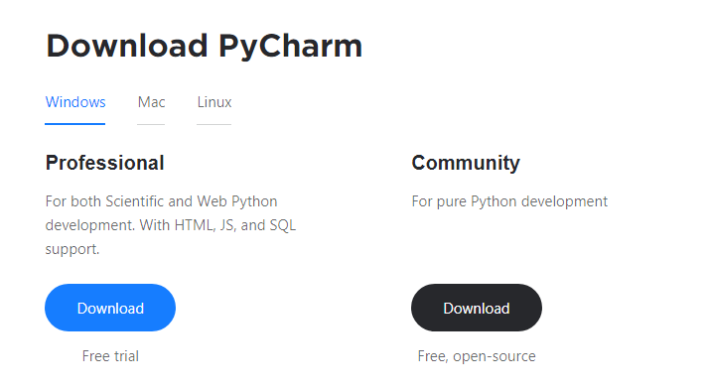

1. Once the download is complete, run the exe for install PyCharm. The setup wizard should have started. Click “Next”.
2. On the next screen, Change the installation path if required. Click “Next”.
3. On the next screen, you can create a desktop shortcut if you want and click on “Next”.
4. Choose the start menu folder. Keep selected Jet Brains and click on “Install”.
5. Wait for the installation to finish.
6. Once installation finished, you should receive a message screen that PyCharm is installed. If you want to go ahead and run it, click the “Run PyCharm Community Edition” box first and click “Finish”.
7. After you click on "Finish," the Following screen will appear.

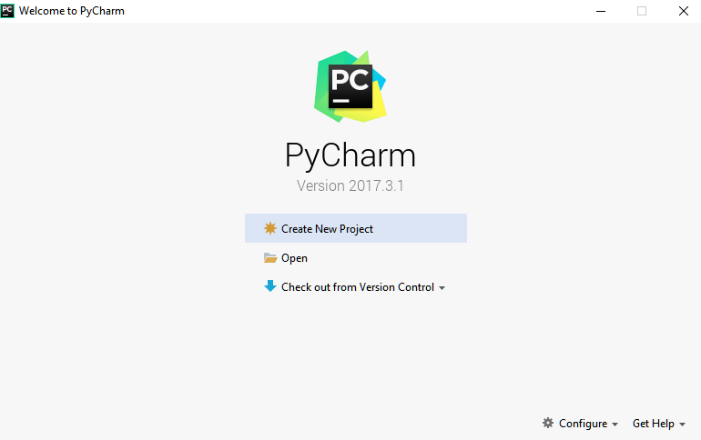

9. You need to install some packages to execute your project in a proper way.

10. Open the command prompt/ anaconda prompt or terminal as administrator.

11. The prompt will get open, with specified path, type “pip install package name” which you want to install (like NumPy, pandas, sea born, scikit-learn, Matplotlib, Pyplot)

Ex: Pip install NumPy

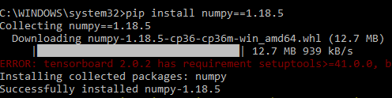

# **INTRODUCTION TO PYTHON**

* Python

### What Is a Script?

Up to this point, I have concentrated on the interactive programming capability of Python.  This is a very useful capability that allows you to type in a program and to have it executed immediately in an interactive mode

Scripts are reusable

Basically, a script is a text file containing the statements that comprise a Python program.  Once you have created the script, you can execute it over and over without having to retype it each time.

Scripts are editable

Perhaps, more importantly, you can make different versions of the script by modifying the statements from one file to the next using a text editor.  Then you can execute each of the individual versions.  In this way, it is easy to create different programs with a minimum amount of typing.

You will need a text editor

Just about any text editor will suffice for creating Python script files.

You can use *Microsoft Notepad, Microsoft WordPad, Microsoft Word,*or just about any word processor if you want to.

Difference between a script and a program

Script:

Scripts are distinct from the core code of the application, which is usually written in a different language, and are often created or at least modified by the end-user. Scripts are often interpreted from source code or byte code, whereas the applications they control are traditionally compiled to native machine code.

Program:

The program has an executable form that the computer can use directly to execute the instructions.

The same program in its human-readable source code form, from which executable programs are derived (e.g., compiled)

Python

What is Python? Chances you are asking yourself this. You may have found this book because you want to learn to program but don’t know anything about programming languages. Or you may have heard of programming languages like C, C++, C#, or Java and want to know what Python is and how it compares to “big name” languages. Hopefully I can explain it for you.

Python concepts

If you’re not interested in the how’s and whys of Python, feel free to skip to the next chapter. In this chapter I will try to explain to the reader why I think Python is one of the best languages available and why it’s a great one to start programming with.

• Open-source general-purpose language.

• Object Oriented, Procedural, Functional

• Easy to interface with C/ObjC/Java/Fortran

• Easy-is to interface with C++ (via SWIG)

• Great interactive environment

• Great interactive environment

Python is a high-level, interpreted, interactive and object-oriented scripting language. Python is designed to be highly readable. It uses English keywords frequently where as other languages use punctuation, and it has fewer syntactical constructions than other languages.

* Python is Interpreted − Python is processed at runtime by the interpreter. You do not need to compile your program before executing it. This is similar to PERL and PHP.
* Python is Interactive − you can actually sit at a Python prompt and interact with the interpreter directly to write your programs.
* Python is Object-Oriented − Python supports Object-Oriented style or technique of programming that encapsulates code within objects.
* Python is a Beginner's Language − Python is a great language for the beginner-level programmers and supports the development of a wide range of applications from simple text processing to WWW browsers to games.

History of Python

Python was developed by Guido van Possum in the late eighties and early nineties at the National Research Institute for Mathematics and Computer Science in the Netherlands.

Python is derived from many other languages, including ABC, Modula-3, C, C++, Algol-68, Smalltalk, and UNIX shell and other scripting languages.

Python is copyrighted. Like Perl, Python source code is now available under the GNU General Public License (GPL).

Python is now maintained by a core development team at the institute, although Guido van Possum still holds a vital role in directing its progress.

Python Features

Python's features include −

* Easy-to-learn − Python has few keywords, simple structure, and a clearly defined syntax. This allows the student to pick up the language quickly.
* Easy-to-read − Python code is more clearly defined and visible to the eyes.
* Easy-to-maintain − Python's source code is fairly easy-to-maintained.
* A broad standard library − Python's bulk of the library is very portable and cross-platform compatible on UNIX, Windows, and Macintosh.
* Interactive Mode − Python has support for an interactive mode which allows interactive testing and debugging of snippets of code.
* Portable − Python can run on a wide variety of hardware platforms and has the same interface on all platforms.
* Extendable − you can add low-level modules to the Python interpreter. These modules enable programmers to add to or customize their tools to be more efficient.
* Databases − Python provides interfaces to all major commercial databases.
* GUI Programming − Python supports GUI applications that can be created and ported to many system calls, libraries and windows systems, such as Windows MFC, Macintosh, and the X Window system of Unix.
* Scalable − Python provides a better structure and support for large programs than shell scripting.

Apart from the above-mentioned features, Python has a big list of good features, few are listed below −

* It supports functional and structured programming methods as well as OOP.
* It can be used as a scripting language or can be compiled to byte-code for building large applications.
* It provides very high-level dynamic data types and supports dynamic type checking.
* IT supports automatic garbage collection.
* It can be easily integrated with C, C++, COM, ActiveX, CORBA, and Java.

Dynamic vs. Static

Types Python is a dynamic-typed language. Many other languages are static typed, such as C/C++ and Java. A static typed language requires the programmer to explicitly tell the computer what type of “thing” each data value is.

For example, in C if you had a variable that was to contain the price of something, you would have to declare the variable as a “float” type.

This tells the compiler that the only data that can be used for that variable must be a floating point number, i.e. a number with a decimal point.

If any other data value was assigned to that variable, the compiler would give an error when trying to compile the program.

Python, however, doesn’t require this. You simply give your variables names and assign values to them. The interpreter takes care of keeping track of what kinds of objects your program is using. This also means that you can change the size of the values as you develop the program. Say you have another decimal number (a.k.a. a floating point number) you need in your program.

With a static typed language, you have to decide the memory size the variable can take when you first initialize that variable. A double is a floating point value that can handle a much larger number than a normal float (the actual memory sizes depend on the operating environment).

If you declare a variable to be a float but later on assign a value that is too big to it, your program will fail; you will have to go back and change that variable to be a double.

With Python, it doesn’t matter. You simply give it whatever number you want and Python will take care of manipulating it as needed. It even works for derived values.

For example, say you are dividing two numbers. One is a floating point number and one is an integer. Python realizes that it’s more accurate to keep track of decimals so it automatically calculates the result as a floating point number

Variables

Variables are nothing but reserved memory locations to store values. This means that when you create a variable you reserve some space in memory.

Based on the data type of a variable, the interpreter allocates memory and decides what can be stored in the reserved memory. Therefore, by assigning different data types to variables, you can store integers, decimals or characters in these variables.

Standard Data Types

The data stored in memory can be of many types. For example, a person's age is stored as a numeric value and his or her address is stored as alphanumeric characters. Python has various standard data types that are used to define the operations possible on them and the storage method for each of them.

Python has five standard data types −

* Numbers
* String
* List
* Tuple
* Dictionary

## Python Numbers

Number data types store numeric values. Number objects are created when you assign a value to them

## Python Strings

Strings in Python are identified as a contiguous set of characters represented in the quotation marks. Python allows for either pairs of single or double quotes. Subsets of strings can be taken using the slice operator ([ ] and [:]) with indexes starting at 0 in the beginning of the string and working their way from -1 at the end.

## Python Lists

Lists are the most versatile of Python's compound data types. A list contains items separated by commas and enclosed within square brackets ([]). To some extent, lists are similar to arrays in C. One difference between them is that all the items belonging to a list can be of different data type.

The values stored in a list can be accessed using the slice operator ([ ] and [:]) with indexes starting at 0 in the beginning of the list and working their way to end -1. The plus (+) sign is the list concatenation operator, and the asterisk (*) is the repetition operator.

## Python Tuples

A tuple is another sequence data type that is similar to the list. A tuple consists of a number of values separated by commas. Unlike lists, however, tuples are enclosed within parentheses.

The main differences between lists and tuples are: Lists are enclosed in brackets ([ ]) and their elements and size can be changed, while tuples are enclosed in parentheses (( )) and cannot be updated. Tuples can be thought of as read-only lists.

## Python Dictionary

Python's dictionaries are kind of hash table type. They work like associative arrays or hashes found in Perl and consist of key-value pairs. A dictionary key can be almost any Python type, but are usually numbers or strings. Values, on the other hand, can be any arbitrary Python object.

Dictionaries are enclosed by curly braces ({ }) and values can be assigned and accessed using square braces ([]).

Different modes in python

Python has two basic modes: normal and interactive.

The normal mode is the mode where the scripted and finished .pie files are run in the Python interpreter.

Interactive mode is a command line shell which gives immediate feedback for each statement, while running previously fed statements in active memory. As new lines are fed into the interpreter, the fed program is evaluated both in part and in whole

# 20 Python libraries

1. Requests. The most famous http library written by Kenneth remits. It’s a must have for every python developer.

2. Scrappy. If you are involved in web scraping then this is a must have library for you. After using this library you won’t use any other.

3. Python. A guy toolkit for python. I have primarily used it in place of tinder. You will really love it.

4. Pillow. A friendly fork of PIL (Python Imaging Library). It is more user friendly than PIL and is a must have for anyone who works with images.

5. SQL Alchemy. A database library. Many love it and many hate it. The choice is yours.

6. Beautiful Soup. I know it’s slow but this xml and html parsing library is very useful for beginners.

7. Twisted. The most important tool for any network application developer. It has a very beautiful ape and is used by a lot of famous python developers.

8. Numbly. How can we leave this very important library? It provides some advance math functionalities to python.

9. Skippy. When we talk about numbly then we have to talk about spicy. It is a library of algorithms and mathematical tools for python and has caused many scientists to switch from ruby to python.

10. Matplotlib. A numerical plotting library. It is very useful for any data scientist or any data analyzer.

11. Pygmy. Which developer does not like to play games and develop them? This library will help you achieve your goal of 2d game development.

12. Piglet. A 3d animation and game creation engine. This is the engine in which the famous [python port](https://github.com/fogleman/Minecraft) of mine craft was made

13. Pit. A GUI toolkit for python. It is my second choice after python for developing GUI’s for my python scripts.

14. Pit. Another python GUI library. It is the same library in which the famous Bit torrent client is created.

15. Scaly. A packet sniffer and analyzer for python made in python.

16. Pywin32. A python library which provides some useful methods and classes for interacting with windows.

17. Notch. Natural Language Toolkit – I realize most people won’t be using this one, but it’s generic enough. It is a very useful library if you want to manipulate strings. But its capacity is beyond that. Do check it out.

18. Nose. A testing framework for python. It is used by millions of python developers. It is a must have if you do test driven development.

19. Simply. Simply can do algebraic evaluation, differentiation, expansion, complex numbers, etc. It is contained in a pure Python distribution.

20. I Python. I just can’t stress enough how useful this tool is. It is a python prompt on steroids. It has completion, history, shell capabilities, and a lot more. Make sure that you take a look at it.

Numpy

Humpy’s main object is the homogeneous multidimensional array. It is a table of elements (usually numbers), all of the same type, indexed by a tuple of positive integers. In numbly dimensions are called axes. The number of axes is rank.

• Offers Matlab-ish capabilities within Python

• Fast array operations

• 2D arrays, multi-D arrays, linear algebra etc.

Matplotlib

• High quality plotting library.

Python class and objects

These are the building blocks of OOP. Class creates a new object. This object can be anything, whether an abstract data concept or a model of a physical object, e.g. a chair. Each class has individual characteristics unique to that class, including variables and methods. Classes are very powerful and currently “the big thing” in most programming languages. Hence, there are several chapters dedicated to OOP later in the book.

The class is the most basic component of object-oriented programming. Previously, you learned how to use functions to make your program do something.

Now will move into the big, scary world of Object-Oriented Programming (OOP). To be honest, it took me several months to get a handle on objects.

When I first learned C and C++, I did great; functions just made sense for me.

Having messed around with BASIC in the early ’90s, I realized functions were just like subroutines so there wasn’t much new to learn.

However, when my C++ course started talking about objects, classes, and all the new features of OOP, my grades definitely suffered.

Once you learn OOP, you’ll realize that it’s actually a pretty powerful tool. Plus many Python libraries and APIs use classes, so you should at least be able to understand what the code is doing.

One thing to note about Python and OOP: it’s not mandatory to use objects in your code in a way that works best; maybe you don’t need to have a full-blown class with initialization code and methods to just return a calculation. With Python, you can get as technical as you want.

As you’ve already seen, Python can do just fine with functions. Unlike languages such as Java, you aren’t tied down to a single way of doing things; you can mix functions and classes as necessary in the same program. This lets you build the code

Objects are an encapsulation of variables and functions into a single entity. Objects get their variables and functions from classes. Classes are essentially a template to create your objects.

Here’s a brief list of Python OOP ideas:

• The class statement creates a class object and gives it a name. This creates a new namespace.

• Assignments within the class create class attributes. These attributes are accessed by qualifying the name using dot syntax: ClassName.Attribute.

• Class attributes export the state of an object and its associated behavior. These attributes are shared by all instances of a class.

• Calling a class (just like a function) creates a new instance of the class.

This is where the multiple copies part comes in.

• Each instance gets ("inherits") the default class attributes and gets its own namespace. This prevents instance objects from overlapping and confusing the program.

• Using the term self identifies a particular instance, allowing for per-instance attributes. This allows items such as variables to be associated with a particular instance.

Inheritance

First off, classes allow you to modify a program without really making changes to it.

To elaborate, by sub classing a class, you can change the behaviour of the program by simply adding new components to it rather than rewriting the existing components.

As we’ve seen, an instance of a class inherits the attributes of that class.

However, classes can also inherit attributes from other classes. Hence, a subclass inherits from a superclass allowing you to make a generic superclass that is specialized via subclasses.

The subclasses can override the logic in a superclass, allowing you to change the behavior of your classes without changing the superclass at all.

Operator Overloads

Operator overloading simply means that objects that you create from classes can respond to actions (operations) that are already defined within Python, such as addition, slicing, printing, etc.

Even though these actions can be implemented via class methods, using overloading ties the behavior closer to Python’s object model and the object interfaces are more consistent to Python’s built-in objects, hence overloading is easier to learn and use.

User-made classes can override nearly all of Python’s built-in operation methods

Exceptions

I’ve talked about exceptions before but now I will talk about them in depth. Essentially, exceptions are events that modify program’s flow, either intentionally or due to errors.

They are special events that can occur due to an error, e.g. trying to open a file that doesn’t exist, or when the program reaches a marker, such as the completion of a loop.

Exceptions, by definition, don’t occur very often; hence, they are the "exception to the rule" and a special class has been created for them. Exceptions are everywhere in Python.

Virtually every module in the standard Python library uses them, and Python itself will raise them in a lot of different circumstances.

Here are just a few examples:

• Accessing a non−existent dictionary key will raise a Key Error exception.

• Searching a list for a non−existent value will raise a Value Error exception

. • Calling a non−existent method will raise an Attribute Error exception.

• Referencing a non−existent variable will raise a Name Error exception.

• Mixing data types without coercion will raise a Type Error exception.

One use of exceptions is to catch a fault and allow the program to continue working; we have seen this before when we talked about files.

This is the most common way to use exceptions. When programming with the Python command line interpreter, you don’t need to worry about catching exceptions.

Your program is usually short enough to not be hurt too much if an exception occurs.

Plus, having the exception occur at the command line is a quick and easy way to tell if your code logic has a problem.

However, if the same error occurred in your real program, it will fail and stop working. Exceptions can be created manually in the code by raising an exception.

It operates exactly as a system-caused exceptions, except that the programmer is doing it on purpose. This can be for a number of reasons. One of the benefits of using exceptions is that, by their nature, they don’t put any overhead on the code processing.

Because exceptions aren’t supposed to happen very often, they aren’t processed until they occur.

Exceptions can be thought of as a special form of the if/elf statements. You can realistically do the same thing with if blocks as you can with exceptions.

However, as already mentioned, exceptions aren’t processed until they occur; if blocks are processed all the time.

Proper use of exceptions can help the performance of your program.

The more infrequent the error might occur, the better off you are to use exceptions; using if blocks requires Python to always test extra conditions before continuing.

Exceptions also make code management easier: if your programming logic is mixed in with error-handling if statements, it can be difficult to read, modify, and debug your program.

User-Defined Exceptions

I won’t spend too much time talking about this, but Python does allow for a programmer to create his own exceptions.

You probably won’t have to do this very often but it’s nice to have the option when necessary.

However, before making your own exceptions, make sure there isn’t one of the built-in exceptions that will work for you.

They have been "tested by fire" over the years and not only work effectively, they have been optimized for performance and are bug-free.

Making your own exceptions involves object-oriented programming, which will be covered in the next chapter

. To make a custom exception, the programmer determines which base exception to use as the class to inherit from, e.g. making an exception for negative numbers or one for imaginary numbers would probably fall under the Arithmetic Error exception class.

To make a custom exception, simply inherit the base exception and define what it will do.

Python modules

Python allows us to store our code in files (also called modules). This is very useful for more serious programming, where we do not want to retype a long function definition from the very beginning just to change one mistake. In doing this, we are essentially defining our own modules, just like the modules defined already in the Python library.

To support this, Python has a way to put definitions in a file and use them in a script or in an interactive instance of the interpreter. Such a file is called a module; definitions from a module can be imported into other modules or into the main module.

Testing code

As indicated above, code is usually developed in a file using an editor.

To test the code, import it into a Python session and try to run it.

Usually there is an error, so you go back to the file, make a correction, and test again.

This process is repeated until you are satisfied that the code works. T

His entire process is known as the development cycle.

There are two types of errors that you will encounter. Syntax errors occur when the form of some command is invalid.

This happens when you make typing errors such as misspellings, or call something by the wrong name, and for many other reasons. Python will always give an error message for a syntax error.

Functions in Python

It is possible, and very useful, to define our own functions in Python. Generally speaking, if you need to do a calculation only once, then use the interpreter. But when you or others have need to perform a certain type of calculation many times, then define a function.

You use functions in programming to bundle a set of instructions that you want to use repeatedly or that, because of their complexity, are better self-contained in a sub-program and called when needed. That means that a function is a piece of code written to carry out a specified task.

## To carry out that specific task, the function might or might not need multiple inputs. When the task is carved out, the function can or cannot return one or more values.

## There are three types of functions in python:

## Help (), min (), print ().

Namespaces in Python are implemented as Python dictionaries, this means it is a mapping from names (keys) to objects (values). The user doesn't have to know this to write a Python program and when using namespaces.

Some namespaces in Python:

* global names of a module
* local names in a function or method invocation
* built-in names: this namespace contains built-in functions (e.g. abs(), camp(), ...) and built-in exception names

Garbage Collection

Garbage Collector exposes the underlying memory management mechanism of Python, the automatic garbage collector. The module includes functions for controlling how the collector operates and to examine the objects known to the system, either pending collection or stuck in reference cycles and unable to be freed.

Python XML Parser

XML is a portable, open source language that allows programmers to develop applications that can be read by other applications, regardless of operating system and/or developmental language.

What is XML? The Extensible Markup Language XML is a markup language much like HTML or SGML.

This is recommended by the World Wide Web Consortium and available as an open standard.

XML is extremely useful for keeping track of small to medium amounts of data without requiring a SQL-based backbone.

XML Parser Architectures and APIs the Python standard library provides a minimal but useful set of interfaces to work with XML.

The two most basic and broadly used APIs to XML data are the SAX and DOM interfaces.

Simple API for XML SAX: Here, you register call-backs for events of interest and then let the parser proceed through the document.

This is useful when your documents are large or you have memory limitations, it parses the file as it reads it from disk and the entire file is never stored in memory.

Document Object Model DOM API : This is a World Wide Web Consortium recommendation wherein the entire file is read into memory and stored in a hierarchical tree − based form to represent all the features of an XML document.

SAX obviously cannot process information as fast as DOM can when working with large files. On the other hand, using DOM exclusively can really kill your resources, especially if used on a lot of small files.

SAX is read-only, while DOM allows changes to the XML file. Since these two different APIs literally complement each other, there is no reason why you cannot use them both for large projects.

Python Web Frameworks

A web framework is a code library that makes a developer's life easier when building reliable, scalable and maintainable web applications.

## Why are web frameworks useful?

Web frameworks encapsulate what developers have learned over the past twenty years while programming sites and applications for the web. Frameworks make it easier to reuse code for common HTTP operations and to structure projects so other developers with knowledge of the framework can quickly build and maintain the application.

Common web framework functionality

Frameworks provide functionality in their code or through extensions to perform common operations required to run web applications. These common operations include:

1. URL routing
2. HTML, XML, JSON, and other output format tinplating
3. Database manipulation
4. Security against Cross-site request forgery (CSRF) and other attacks
5. Session storage and retrieval

Not all web frameworks include code for all of the above functionality. Frameworks fall on the spectrum from executing a single use case to providing every known web framework feature to every developer. Some frameworks take the "batteries-included" approach where everything possible comes bundled with the framework while others have a minimal core package that is amenable to extensions provided by other packages.

## Comparing web frameworks

There is also a repository called [compare-python-web-frameworks](https://github.com/mattmakai/compare-python-web-frameworks) where the same web application is being coded with varying Python web frameworks, tinplating engines and object.

## Web framework resources

* When you are learning how to use one or more web frameworks it's helpful to have an idea of what the code under the covers is doing.
* Frameworks is a really well done short video that explains how to choose between web frameworks. The author has some particular opinions about what should be in a framework. For the most part I agree although I've found sessions and database ORMs to be a helpful part of a framework when done well.
* What is a web framework? Is an in-depth explanation of what web frameworks are and their relation to web servers?
* Jingo vs. Flash vs. Pyramid: Choosing a Python web framework contains background information and code comparisons for similar web applications built in these three big Python frameworks.
* This fascinating blog post takes a look at the code complexity of several Python web frameworks by providing visualizations based on their code bases.
* Python’s web frameworks benchmarks  is a test of the responsiveness of a framework with encoding an object to JSON and returning it as a response as well as retrieving data from the database and rendering it in a template. There were no conclusive results but the output is fun to read about nonetheless.
* What web frameworks do you use and why are they awesome? Is a language agnostic Reedit discussion on web frameworks? It's interesting to see what programmers in other languages like and dislike about their suite of web frameworks compared to the main Python frameworks.
* This user-voted question & answer site asked "What are the best general purpose Python web frameworks usable in production?” The votes aren't as important as the list of the many frameworks that are available to Python developers.

## Web frameworks learning checklist

1. Choose a major Python web framework (Jingo or Flask are recommended) and stick with it. When you're just starting it's best to learn one framework first instead of bouncing around trying to understand every framework.
2. Work through a detailed tutorial found within the resources links on the framework's page.
3. Study open source examples built with your framework of choice so you can take parts of those projects and reuse the code in your application.
4. Build the first simple iteration of your web application then go to the [deployment](https://www.fullstackpython.com/deployment.html) section to make it accessible on the web.

2. SYSTEM STUDY

### SYSTEM TESTING

The purpose of testing is to discover errors. Testing is the process of trying to discover every conceivable fault or weakness in a work product. It provides a way to check the functionality of components, sub-assemblies, assemblies and/or a finished product It is the process of exercising software with the intent of ensuring that the

Software system meets its requirements and user expectations and does not fail in an unacceptable manner. There are various types of test. Each test type addresses a specific testing requirement.

TYPES OF TESTS

Unit testing

Unit testing involves the design of test cases that validate that the internal program logic is functioning properly, and that program inputs produce valid outputs. All decision branches and internal code flow should be validated. It is the testing of individual software units of the application .it is done after the completion of an individual unit before integration. This is a structural testing, that relies on knowledge of its construction and is invasive. Unit tests perform basic tests at component level and test a specific business process, application, and/or system configuration. Unit tests ensure that each unique path of a business process performs accurately to the documented specifications and contains clearly defined inputs and expected results.

Integration testing

Integration tests are designed to test integrated software components to determine if they actually run as one program. Testing is event driven and is more concerned with the basic outcome of screens or fields. Integration tests demonstrate that although the components were individually satisfaction, as shown by successfully unit testing, the combination of components is correct and consistent. Integration testing is specifically aimed at exposing the problems that arise from the combination of components.

Functional test

Functional tests provide systematic demonstrations that functions tested are available as specified by the business and technical requirements, system documentation, and user manuals.

Functional testing is centered on the following items:

Valid Input : identified classes of valid input must be accepted.

Invalid Input : identified classes of invalid input must be rejected.

Functions : identified functions must be exercised.

Output : identified classes of application outputs must be exercised.

Systems/Procedures: interfacing systems or procedures must be invoked.

Organization and preparation of functional tests is focused on requirements, key functions, or special test cases. In addition, systematic coverage pertaining to identify Business process flows; data fields, predefined processes, and successive processes must be considered for testing. Before functional testing is complete, additional tests are identified and the effective value of current tests is determined.

SYSTEM TEST

System testing ensures that the entire integrated software system meets requirements. It tests a configuration to ensure known and predictable results. An example of system testing is the configuration oriented system integration test. System testing is based on process descriptions and flows, emphasizing pre-driven process links and integration points.

White Box Testing

White Box Testing is a testing in which in which the software tester has knowledge of the inner workings, structure and language of the software, or at least its purpose. It is purpose. It is used to test areas that cannot be reached from a black box level.

Black Box Testing

Black Box Testing is testing the software without any knowledge of the inner workings, structure or language of the module being tested. Black box tests, as most other kinds of tests, must be written from a definitive source document, such as specification or requirements document, such as specification or requirements document. It is a testing in which the software under test is treated, as a black box .you cannot “see” into it. The test provides inputs and responds to outputs without considering how the software works.

6.1 Unit Testing:

Unit testing is usually conducted as part of a combined code and unit test phase of the software lifecycle, although it is not uncommon for coding and unit testing to be conducted as two distinct phases.

Test strategy and approach

Field testing will be performed manually and functional tests will be written in detail.

Test objectives

* All field entries must work properly.
* Pages must be activated from the identified link.
* The entry screen, messages and responses must not be delayed.

Features to be tested

* Verify that the entries are of the correct format
* No duplicate entries should be allowed
* All links should take the user to the correct page.

# 6.2 Integration Testing

Software integration testing is the incremental integration testing of two or more integrated software components on a single platform to produce failures caused by interface defects.

The task of the integration test is to check that components or software applications, e.g. components in a software system or – one step up – software applications at the company level – interact without error.

Test Results: All the test cases mentioned above passed successfully. No defects encountered.

6.3 Acceptance Testing

User Acceptance Testing is a critical phase of any project and requires significant participation by the end user. It also ensures that the system meets the functional requirements.

Test Results: All the test cases mentioned above passed successfully. No defects encountered.